Multithreading assignment

- Create and Run a Thread using Runnable Interface and Thread class.
//using Runnable interface
public class ThreadNew implements Runnable{
@Override
public void run() {
System.out.println("Running new thread using runnable interface");
}
public static void main(String[] args) {
new Thread(new ThreadNew()).start();
}
}
Output:


//extending thread class
public class ThreadNew extends Thread{
@Override
public void run() {
System.out.println("Running new thread by extending Thread class");
}
public static void main(String[] args) {
new ThreadNew().start();
}
}
Output:

- Use sleep and join methods with thread.

public class ThreadNew {
public static void main(String[] args) {
System.out.println("main started: "+Thread.currentThread().getName());
Thread thread1=new Thread(new Runnable() {
@Override
public void run() {
try {
Thread.sleep(2000L);
System.out.println("running: "+Thread.currentThread().getName());
} catch (InterruptedException e) {
e.printStackTrace();
}
}
});
thread1.start();
//joining thread one
/*Although thread-0 is sleep for 2 second,
but as we joined it, Thread-1 will have to wait until it finishes*/
try {
thread1.join();
} catch (InterruptedException e) {
e.printStackTrace();
}
Thread thread2=new Thread(new Runnable() {
@Override
public void run() {
System.out.println("running: "+Thread.currentThread().getName());
}
});
thread2.start();
System.out.println("main ended: "+Thread.currentThread().getName());
}
}
Output:
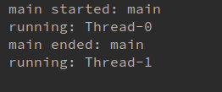

- Use a singleThreadExecutor to submit multiple threads.
import java.util.concurrent.Executor;
import java.util.concurrent.ExecutorService;
import java.util.concurrent.Executors;
public class ThreadNew {
public static void main(String[] args) {
System.out.println("main started: "+Thread.currentThread().getName());
ExecutorService executorService= Executors.newSingleThreadExecutor();
try{
executorService.submit(new Runnable() {
@Override
public void run() {
System.out.println(Thread.currentThread().getName());
}
});
executorService.submit(new Runnable() {
@Override
public void run() {
System.out.println(Thread.currentThread().getName());
}
});
executorService.submit(new Runnable() {
@Override
public void run() {
try {
Thread.sleep(2000L);
} catch (InterruptedException e) {
e.printStackTrace();
}
System.out.println(Thread.currentThread().getName());
}
});
}
finally {
executorService.shutdown();
}
System.out.println("isShutdown= "+executorService.isShutdown());
System.out.println("isTerminated= "+executorService.isTerminated());
System.out.println("main ended: "+Thread.currentThread().getName());
}
}
Output:
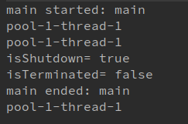

- Try shutdown() and shutdownNow() and observe the difference.
After using, shutdownNow() instead of shutdown() in the above code (i.e. Ques.3). I have observe the following output:
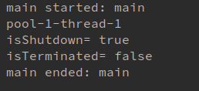

Explanation: Only one task executed before shutdownNow() called, due to it the two upcoming task cancelled.

- Use isShutDown() and isTerminate() with ExecutorService.
import java.util.concurrent.Executor;
import java.util.concurrent.ExecutorService;
import java.util.concurrent.Executors;
public class ThreadNew {
public static void main(String[] args) {
System.out.println("main started: "+Thread.currentThread().getName());
ExecutorService executorService= Executors.newSingleThreadExecutor();
try{
executorService.submit(new Runnable() {
@Override
public void run() {
System.out.println(Thread.currentThread().getName());
}
});
executorService.submit(new Runnable() {
@Override
public void run() {
System.out.println(Thread.currentThread().getName());
}
});
executorService.submit(new Runnable() {
@Override
public void run() {
try {
Thread.sleep(2000L);
} catch (InterruptedException e) {
e.printStackTrace();
}
System.out.println(Thread.currentThread().getName());
}
});
}
finally {
executorService.shutdown();
}
System.out.println("isShutdown= "+executorService.isShutdown());
System.out.println("isTerminated= "+executorService.isTerminated());
System.out.println("main ended: "+Thread.currentThread().getName());
}
}
Output:
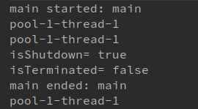

- Return a Future from ExecutorService by using callable and use get(), isDone(), isCancelled() with the Future object to know the status of task submitted.
import java.util.concurrent.*;
public class ThreadNew {
public static void main(String[] args) {
ExecutorService executorService=Executors.newSingleThreadExecutor();
Future<Integer> future=executorService.submit(new Callable<Integer>() {
@Override
public Integer call() throws Exception {
System.out.println(Thread.currentThread().getName());
return 10;
}
});
executorService.shutdownNow();
try {
Thread.sleep(1000L);
} catch (InterruptedException e) {
e.printStackTrace();
}
if(future.isDone())
{
try {
System.out.println(future.get());
}
catch (InterruptedException e) {
e.printStackTrace();
}
catch (ExecutionException e) {
e.printStackTrace();
}
}
if(future.isCancelled())
{
System.out.println("Your task has been cancelled");
}
else
System.out.println("task was not cancelled");
}
}
Output:
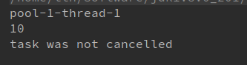

- Submit List of tasks to ExecutorService and wait for the completion of all the tasks.
import org.omg.CORBA.TIMEOUT;
import java.util.ArrayList;
import java.util.List;
import java.util.concurrent.*;
public class ThreadNew {
public static void main(String[] args) throws ExecutionException, InterruptedException {
List<Callable<Integer>> list=new ArrayList<>();
list.add(new Callable<Integer>() {
@Override
public Integer call() throws Exception {
return 1;
}
});
list.add(new Callable<Integer>() {
@Override
public Integer call() throws Exception {
return 2;
}
});
list.add(new Callable<Integer>() {
@Override
public Integer call() throws Exception {
return 3;
}
});
list.add(new Callable<Integer>() {
@Override
public Integer call() throws Exception {
return 4;
}
});
ExecutorService executorService=Executors.newSingleThreadExecutor();
//submitting list of task to ExecutorService
List<Future<Integer>> futures=executorService.invokeAll(list);
executorService.shutdown();
futures.forEach((e)->
{
if(e.isDone()) {
try {
System.out.println(e.get());
} catch (InterruptedException e1) {
e1.printStackTrace();
} catch (ExecutionException e1) {
e1.printStackTrace();
}
}
});
executorService.awaitTermination(2000L, TimeUnit.MILLISECONDS);
if(executorService.isTerminated())
System.out.println("service terminated");
else
System.out.println("service not terminated");
}
}
Output:
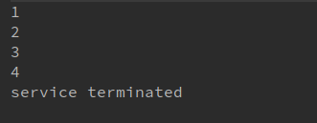

- Schedule task using schedule(), scheduleAtFixedRate() and scheduleAtFixedDelay()
//scheduling task using shedule()
import org.omg.CORBA.TIMEOUT;
import java.util.ArrayList;
import java.util.List;
import java.util.concurrent.*;
public class ThreadNew {
public static void main(String[] args) {
ScheduledExecutorService scheduledExecutorService=Executors.newSingleThreadScheduledExecutor();
scheduledExecutorService.schedule(new Runnable() {
@Override
public void run() {
System.out.println(Thread.currentThread().getName());
}
},1,TimeUnit.SECONDS);
scheduledExecutorService.shutdown();
}
}
Output:
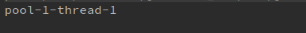

// usingscheduleAtFixedRate() and scheduleAtFixedDelay()
import org.omg.CORBA.TIMEOUT;
import java.util.ArrayList;
import java.util.List;
import java.util.concurrent.*;
public class ThreadNew {
public static void main(String[] args) {
ScheduledExecutorService scheduledExecutorService=Executors.newSingleThreadScheduledExecutor();
scheduledExecutorService.scheduleWithFixedDelay(new Runnable() {
@Override
public void run() {
try {
Thread.sleep(2000L);
System.out.println("scheduleWithFixedDelay scheduled task to be excuted");
} catch (InterruptedException e) {
e.printStackTrace();
}
}
},0,1,TimeUnit.SECONDS);
scheduledExecutorService.scheduleAtFixedRate(new Runnable() {
@Override
public void run() {
try {
Thread.sleep(2000L);
System.out.println("scheduleAtFixedRate scheduled task to be excuted");
} catch (InterruptedException e) {
e.printStackTrace();
}
}
},0,1,TimeUnit.SECONDS);
}
}
Output:
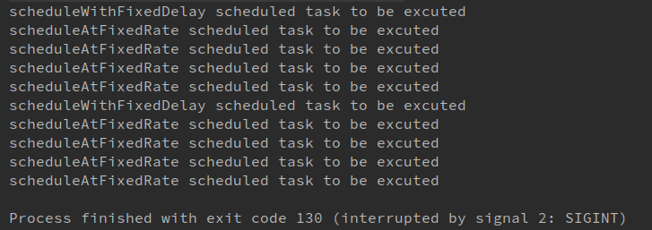

- Increase concurrency with Thread pools using newCachedThreadPool() and newFixedThreadPool().

import java.util.concurrent.ExecutorService;
import java.util.concurrent.Executors;
class Process implements Runnable{
int id;
public Process(int id) {
this.id = id;
}
@Override
public void run() {
System.out.println("Thread name::"+Thread.currentThread().getName()+" Start :"+id);
try {
Thread.sleep(2000L);
} catch (InterruptedException e) {
e.printStackTrace();
}
System.out.println("Thread name::"+Thread.currentThread().getName()+" End :"+id);
}
}
class ExecuterServiceDemo {
public static void main(String[] args) {
// ExecutorService executorService= Executors.newFixedThreadPool(3);
ExecutorService executorService= Executors.newCachedThreadPool();
for (int i = 0; i <= 30; i++) {
executorService.submit(new Process(i));
}
executorService.shutdown();
}
}

Output:
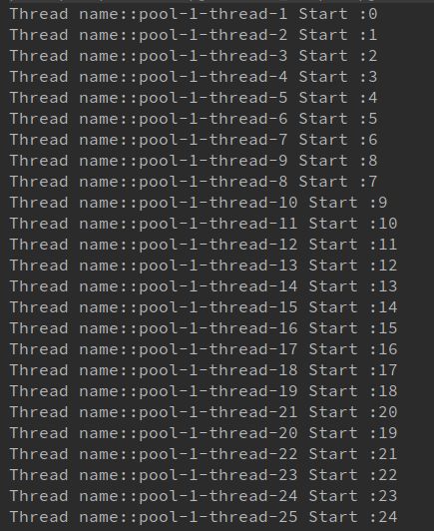

- Use Synchronize method to enable synchronization between multiple threads trying to access method at same time.
class SynchronizeExample {
int count;
synchronized void increment()
{
count++;
}
void worker1()
{
for (int i=0;i<2000;i++)
increment();
}
void worker2(){
for (int i=0;i<2000;i++)
increment();
}
public static void main(String[] args) throws InterruptedException {
SynchronizeExample synchronizeExample=new SynchronizeExample();
Thread thread1=new Thread(new Runnable() {
@Override
public void run() {
synchronizeExample.worker1();
}
});
Thread thread2=new Thread(new Runnable() {
@Override
public void run() {
synchronizeExample.worker2();
}
});
thread1.start();
thread2.start();
thread1.join();
thread2.join();
System.out.println("count= "+synchronizeExample.count);
}
}
Output:


- Use Synchronize block to enable synchronization between multiple threads trying to access method at same time.
class SynchronizeExample {
int count;
void increment()
{
//synchronized block
synchronized (this) {
count++;
}
}
void worker1()
{
for (int i=0;i<1000;i++)
increment();
}
void worker2(){
for (int i=0;i<1000;i++)
increment();
}
public static void main(String[] args) throws InterruptedException {
SynchronizeExample synchronizeExample=new SynchronizeExample();
Thread thread1=new Thread(new Runnable() {
@Override
public void run() {
synchronizeExample.worker1();
}
});
Thread thread2=new Thread(new Runnable() {
@Override
public void run() {
synchronizeExample.worker2();
}
});
thread1.start();
thread2.start();
thread1.join();
thread2.join();
System.out.println("count= "+synchronizeExample.count);
}
}
Output:


- Use Atomic Classes instead of Synchronize method and blocks.
import java.util.concurrent.atomic.AtomicInteger;
class ThreadExample {
//use of Atomic class
AtomicInteger count=new AtomicInteger();
void increment()
{
synchronized (this) {
count.incrementAndGet();
}
}
void worker1()
{
for (int i=0;i<5000;i++)
count.incrementAndGet();
}
void worker2(){
for (int i=0;i<5000;i++)
count.incrementAndGet();
}
public static void main(String[] args) throws InterruptedException {
ThreadExample threadExample=new ThreadExample();
Thread thread1=new Thread(new Runnable() {
@Override
public void run() {
threadExample.worker1();
}
});
Thread thread2=new Thread(new Runnable() {
@Override
public void run() {
threadExample.worker2();
}
});
thread1.start();
thread2.start();
thread1.join();
thread2.join();
System.out.println("count= "+threadExample .count);
}
}
Output:


- Coordinate 2 threads using wait() and notify().

class ThreadExample {
void worker1(){
synchronized (this){
System.out.println("worker1 started");
try {
wait();
} catch (InterruptedException e) {
e.printStackTrace();
}
System.out.println("worker2 done");
}
}
void worker2(){
synchronized (this){
System.out.println("worker2 started");
System.out.println("worker2 done");
notify();
}
}
public static void main(String[] args) throws InterruptedException {
ThreadExample threadExample=new ThreadExample();
Thread thread1=new Thread(new Runnable() {
@Override
public void run() {
threadExample.worker1();
}
});
Thread thread2=new Thread(new Runnable() {
@Override
public void run() {
threadExample.worker2();
}
});
thread1.start();
thread2.start();
}
}
Output:
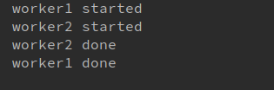

- Coordinate mulitple threads using wait() and notifyAll()

class ThreadExample {
void worker1(){
synchronized (this){
System.out.println("worker1 started");
try {
wait();
} catch (InterruptedException e) {
e.printStackTrace();
}
System.out.println("worker1 done");
}
}
void worker2(){
synchronized (this){
System.out.println("worker2 started");
try {
wait();
} catch (InterruptedException e) {
e.printStackTrace();
}
System.out.println("worker2 done");
}
}
void worker3(){
synchronized (this){
System.out.println("worker3 started");
System.out.println("worker3 done");
notifyAll();
}
}
public static void main(String[] args) throws InterruptedException {
ThreadExample threadExample=new ThreadExample();
Thread thread1=new Thread(new Runnable() {
@Override
public void run() {
threadExample.worker1();
}
});
Thread thread2=new Thread(new Runnable() {
@Override
public void run() {
threadExample.worker2();
}
});
Thread thread3=new Thread(new Runnable() {
@Override
public void run() {
threadExample.worker3();
}
});
thread1.start();
thread2.start();
thread3.start();
}
}
Output:
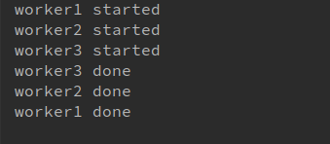

- Use Reentract lock for coordinating 2 threads with signal(), signalAll() and wait().

import java.util.concurrent.locks.Condition;
import java.util.concurrent.locks.Lock;
import java.util.concurrent.locks.ReentrantLock;
class ReentrantLockExample {
Lock lock=new ReentrantLock(true);
Condition condition=lock.newCondition();
void worker1(){
try {
lock.lock();
System.out.println("worker1 started");
condition.await();
System.out.println("worker1 finished");
} catch (InterruptedException e) {
e.printStackTrace();
}
finally {
lock.unlock();
}
}
void worker2(){
lock.lock();
System.out.println("worker2 started");
System.out.println("worker2 finished");
condition.signal();
lock.unlock();
}
public static void main(String[] args) throws InterruptedException {
ReentrantLockExample reentrantLockExample=new ReentrantLockExample();
Thread thread1=new Thread(new Runnable() {
@Override
public void run() {
reentrantLockExample.worker1();
}
});
Thread thread2=new Thread(new Runnable() {
@Override
public void run() {
reentrantLockExample.worker2();
}
});
thread1.start();
thread2.start();
thread1.join();
thread2.join();
}
}

Output:
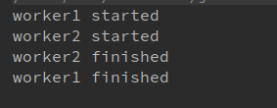

- Create a deadlock and Resolve it using tryLock().
import java.util.concurrent.locks.Lock;
import java.util.concurrent.locks.ReentrantLock;
class SynchronizeExample {
Lock lock1=new ReentrantLock(true);
Lock lock2=new ReentrantLock(true);
void acquireLock(Lock lock1,Lock lock2)
{
boolean acquireLock1=lock1.tryLock();
boolean acquireLock2=lock2.tryLock();
if(acquireLock1 && acquireLock2)
{
return;
}
if(acquireLock1)
{
lock1.unlock();
}
if(acquireLock2)
{
lock2.unlock();
}
}
void worker1(){
acquireLock(lock1,lock2);
System.out.println("lock1 worker1");
System.out.println("lock2 worker1");
lock2.unlock();
lock1.unlock();
}
void worker2(){
acquireLock(lock2,lock1);
System.out.println("lock1 worker2");
System.out.println("lock2 worker2");
lock1.unlock();
lock2.unlock();
}
public static void main(String[] args) throws InterruptedException {
SynchronizeExample synchronizeExample=new SynchronizeExample();
Thread thread1=new Thread(new Runnable() {
@Override
public void run() {
synchronizeExample.worker1();
}
});
Thread thread2=new Thread(new Runnable() {
@Override
public void run() {
synchronizeExample.worker2();
}
});
thread1.start();
thread2.start();
thread1.join();
thread2.join();
}
}
Output:
